Assignment-1

1.Make your own CV.

<!DOCTYPE html>  
<html lang="en">  
<head>  
 <meta charset="UTF-8">  
 <title>cv</title>  
</head>  
<body>  
<div><a id="d1"></a></div>  
<div style="background: #ffffff;"  
<p align="left">  
 <img src="tanisha.jpg" style="width: 100px;height: 100px">  
</p>  
<h1> <a name="top"></a> </h1>  
<div style="border: 1px; border style:solid"></div></solid>  
<h3><b><u>Personal Info:</u></b></h3>  
<font face="impact" size="5">Tanisha Islam</font><br>  
Student <br>  
Date Of Birth: 09.06.2003<br>  
Blood Group: A+<br>  
Address: Rampurhat, Birbhum, PIN-731224  
<br>  
<b>Email Id</b><h1><a  
 href="tanisha.islam@stu.adamasuniversity.ac.in">tanisha.islam@stu.adamasuniversity.ac.in</a> </h1>  
Phone Number:<h1><a target="_blank"  
 href="https://web.whatsapp.com/send/phone=8967408090/&text=welcometo my  
inbox">8967408090</a> </h1>  
<div style="border: 1px; border-style:solid"></div></solid>  
<h3><b><u>Education:</u></b></h3>  
Studied at:<a target_blank href="https://adamasuniversity.ac.in">Adamas University</a>  
<br>  
Pass out H.S:<a target_parent  
 href="https://rampurhatgirlshighshool.com">Rampurhat Girls High School</a>  
<br>  
Pass out 10th: <a target=parenthref="https://paikardewdropschool.in.com">Paikar Dew Drop School</a>  
<br>  
<div style="border:1px; border-style:solid"></div></solid>  
<h3><b><u>Language:</u></b></h3>  
Bengali<br>  
Hindi<br>  
English<br>

</div></background>  
<a href="#d1">CLICK HERE TO GO</a>  
</body>  
</html>

Output:



Assignment-2

2.Create a normal table.

<!DOCTYPE html>  
<html lang="en">  
<head>  
 <meta charset="UTF-8">  
 <meta name="viewport" content="width=device-width, initial-scale=1.0">

<title>Task</title>  
</head>  
<body>  
<table border="2px">  
 <tr>  
 <td colspan="6">Welcome to web programming</td>  
 <td rowspan="6">A</td>  
 </tr>  
 <tr>  
 <td rowspan="6">C</td>  
 <td colspan="4">B</td>  
 <td rowspan="4">K</td>  
 </tr>  
 <tr>  
 <td rowspan="4">D</td>  
 <td colspan="2">L</td>  
 <td rowspan="2">G</td>  
 </tr>  
 <tr>  
 <td rowspan="2">E</td>  
 <td>F</td>  
 </tr>  
 <tr>  
 <td colspan="2">H</td>  
 </tr>

<tr>  
 <td colspan="4">I</td>  
 </tr>  
 <tr>  
 <td colspan="6">J</td>  
 </tr>  
</table>  
</body>  
</html>

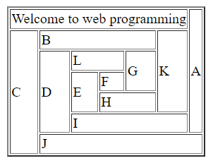Output:

Assignment-3

3.Create a nested table.

<!DOCTYPE html>

<html lang="en">

<head>

<meta charset="UTF-8">

<meta name="viewport" content="width=device-width, initial-scale=1.0">

<title>Assignment Aug 14</title>

</head>

<body>

<table border="2px" cellpadding="20">

<tr>

<td>

A

</td>

<td rowspan="2">

C

</td>

<td rowspan="2" colspan="2">

<table border="2px" cellpadding="10">

<tr>

<td>

K

</td>

<td rowspan="2">

L

</td>

</tr>

<tr>

<td>

M

</td>

</tr>

</table>

</td>

</tr>

<tr>

<td>

B

</td>

</tr>

<tr>

<td colspan="2">

D

</td>

<td rowspan="3">

H

</td>

<td>

J

</td>

</tr>

<tr>

<td>

E

</td>

<td rowspan="2">

G

</td>

<td rowspan="2">

I

</td>

</tr>

<tr>

<td>

F

</td>

</tr>

</table>

</body>

</html>

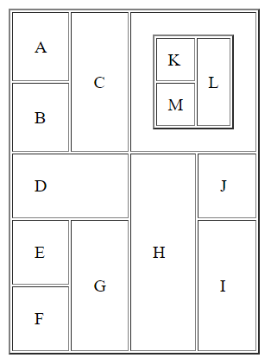Output:

Assignment-4

4. Make a simple calculator using Html, Css and Javascript.

= <!DOCTYPE html>

<html lang="en">

<head>

<meta charset="UTF-8">

<meta name="viewport" content="width=device-width, initial-scale=1.0">

<title>Simple Calculator</title>

<link rel="stylesheet" href="styles.css">

</head>

<body>

<div class="calculator">

<input type="text" id="display" disabled />

<div class="buttons">

<button onclick="clearDisplay()">C</button>

<button onclick="deleteLast()">DEL</button>

<button onclick="appendValue('/')">/</button>

<button onclick="appendValue('')"></button>

<button onclick="appendValue('7')">7</button>

<button onclick="appendValue('8')">8</button>

<button onclick="appendValue('9')">9</button>

<button onclick="appendValue('-')">-</button>

<button onclick="appendValue('4')">4</button>

<button onclick="appendValue('5')">5</button>

<button onclick="appendValue('6')">6</button>

<button onclick="appendValue('+')">+</button>

<button onclick="appendValue('1')">1</button>

<button onclick="appendValue('2')">2</button>

<button onclick="appendValue('3')">3</button>

<button onclick="calculateResult()">=</button>

<button onclick="appendValue('0')">0</button>

<button onclick="appendValue('.')">.</button>

</div>

</div>

<script src="script.js"></script>

</body>

</html>

body {

font-family: Arial, sans-serif;

display: flex;

justify-content: center;

align-items: center;

height: 100vh;

margin: 0;

background-color: #f4f4f4;

}

.calculator {

width: 200px;

background-color: #333;

padding: 20px;

border-radius: 10px;

}

#display {

width: 100%;

height: 40px;

text-align: right;

padding: 10px;

font-size: 18px;

margin-bottom: 10px;

border: none;

border-radius: 5px;

}

.buttons {

display: grid;

grid-template-columns: repeat(4, 1fr);

gap: 10px;

}

button {

width: 100%;

height: 40px;

font-size: 18px;

background-color: #444;

color: white;

border: none;

border-radius: 5px;

cursor: pointer;

}

button:hover {

background-color: #555;

}

// Script for Calculator

let display = document.getElementById("display");

// Function to append value to the display

function appendValue(value) {

display.value += value;

}

// Function to clear the display

function clearDisplay() {

display.value = "";

}

// Function to delete the last character in the display

function deleteLast() {

display.value = display.value.slice(0, -1);

}

// Function to calculate the result

function calculateResult() {

try {

display.value = eval(display.value);

} catch (error) {

display.value = "Error";

}

}

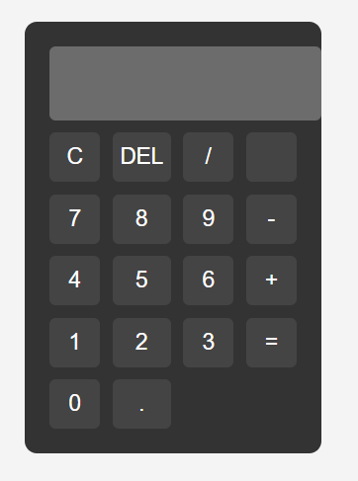Output:

5. Make a scientific calculator using Html, Css and Javascript.

=<!DOCTYPE html>

<html lang="en">

<head>

<meta charset="UTF-8">

<meta name="viewport" content="width=device-width, initial-scale=1.0">

<title>Scientific Calculator</title>

<link rel="stylesheet" href="styles.css">

</head>

<body>

<div class="calculator">

<input type="text" id="display" disabled>

<div class="buttons">

<button onclick="clearDisplay()">C</button>

<button onclick="backspace()">⌫</button>

<button onclick="appendOperator('(')">(</button>

<button onclick="appendOperator(')')">)</button>

<button onclick="appendOperator('sin(')">sin</button>

<button onclick="appendOperator('cos(')">cos</button>

<button onclick="appendOperator('tan(')">tan</button>

<button onclick="appendOperator('√(')">√</button>

<button onclick="appendOperator('^')">^</button>

<button onclick="appendOperator('log(')">log</button>

<button onclick="appendOperator('ln(')">ln</button>

<button onclick="appendOperator('/')">/</button>

<button onclick="appendNumber(7)">7</button>

<button onclick="appendNumber(8)">8</button>

<button onclick="appendNumber(9)">9</button>

<button onclick="appendOperator('')"></button>

<button onclick="appendNumber(4)">4</button>

<button onclick="appendNumber(5)">5</button>

<button onclick="appendNumber(6)">6</button>

<button onclick="appendOperator('-')">-</button>

<button onclick="appendNumber(1)">1</button>

<button onclick="appendNumber(2)">2</button>

<button onclick="appendNumber(3)">3</button>

<button onclick="appendOperator('+')">+</button>

<button onclick="appendNumber(0)">0</button>

<button onclick="appendNumber('.')">.</button>

<button onclick="calculate()">=</button>

</div>

</div>

<script src="script.js"></script>

</body>

</html>

body {

display: flex;

justify-content: center;

align-items: center;

height: 100vh;

margin: 0;

background-color: #f4f4f4;

font-family: Arial, sans-serif;

}

.calculator {

border: 2px solid #333;

border-radius: 10px;

padding: 20px;

background-color: #fff;

box-shadow: 0px 0px 10px rgba(0, 0, 0, 0.1);

}

#display {

width: 100%;

height: 40px;

font-size: 1.5rem;

text-align: right;

margin-bottom: 10px;

padding: 5px;

}

.buttons {

display: grid;

grid-template-columns: repeat(4, 1fr);

gap: 10px;

}

button {

padding: 15px;

font-size: 1.2rem;

border-radius: 5px;

border: 1px solid #333;

background-color: #f0f0f0;

cursor: pointer;

}

button:active {

background-color: #ddd;

}

button:nth-child(4n) {

background-color: #f9a825;

}

button:nth-child(4n):active {

background-color: #f57f17;

}

let display = document.getElementById('display');

function appendNumber(number) {

display.value += number;

}

function appendOperator(operator) {

display.value += operator;

}

function clearDisplay() {

display.value = '';

}

function backspace() {

display.value = display.value.slice(0, -1);

}

function calculate() {

try {

let expression = display.value;

// Handle power operation (^)

expression = expression.replace(/\^/g, '');

// Handle square root (√)

expression = expression.replace(/√/g, 'Math.sqrt');

// Replace math functions

expression = expression.replace(/sin/g, 'Math.sin');

expression = expression.replace(/cos/g, 'Math.cos');

expression = expression.replace(/tan/g, 'Math.tan');

expression = expression.replace(/log/g, 'Math.log10');

expression = expression.replace(/ln/g, 'Math.log');

// Evaluate the expression

display.value = eval(expression);

} catch (error) {

display.value = 'Error';

}

}

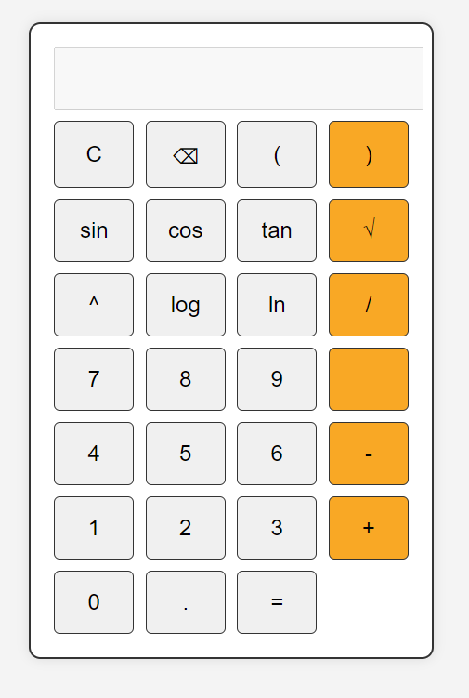Output:

Assignment:5

6. Write a javascript to build a tellycounter app which can count some activities based on some triggers.

= <!DOCTYPE html>

<html lang="en">

<head>

<meta charset="UTF-8">

<meta name="viewport" content="width=device-width, initial-scale=1.0">

<title>Tally Counter</title>

<style>

body {

font-family: Arial, sans-serif;

text-align: center;

padding: 20px;

}

.counter {

margin: 20px;

}

button {

padding: 10px 20px;

font-size: 16px;

margin: 10px;

cursor: pointer;

}

.counter-value {

font-size: 24px;

font-weight: bold;

}

</style>

</head>

<body>

<h1>Tally Counter App</h1>

<div class="counter">

<h3>Activity 1</h3>

<p class="counter-value" id="activity1-count">0</p>

<button onclick="incrementCounter('activity1')">Increment Activity 1</button>

</div>

<div class="counter">

<h3>Activity 2</h3>

<p class="counter-value" id="activity2-count">0</p>

<button onclick="incrementCounter('activity2')">Increment Activity 2</button>

</div>

<div class="counter">

<h3>Activity 3</h3>

<p class="counter-value" id="activity3-count">0</p>

<button onclick="incrementCounter('activity3')">Increment Activity 3</button>

</div>

<script src="tallycounter.js"></script>

</body>

</html>

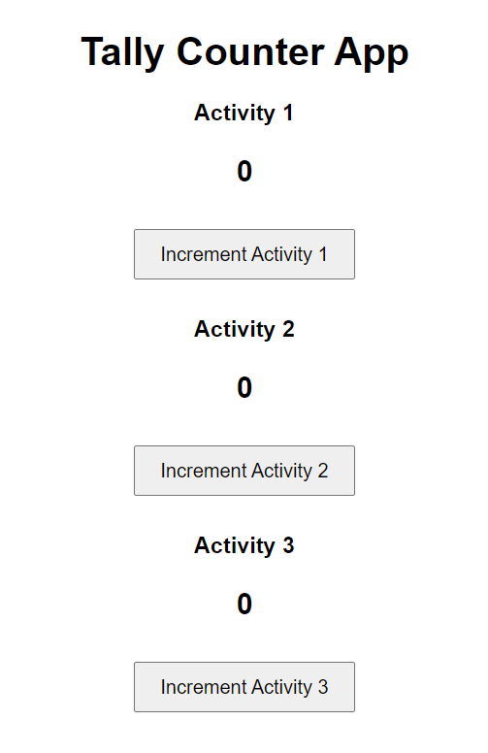Output:

7. Create a form validation using javascript which validates the elements of form such that -(i)No field can be empty,(ii)Password should have 8 charecters 1 special,1 uppercase and 1 lowercase,1 digit,(iii)email should cotain @ and dot

= <!DOCTYPE html>

<html lang="en">

<head>

<meta charset="UTF-8">

<meta name="viewport" content="width=device-width, initial-scale=1.0">

<title>Form Validation</title>

</head>

<body>

<form id="myForm" onsubmit="return validateForm()">

<label for="username">Username:</label>

<input type="text" id="username" name="username">

<br><br>

<label for="email">Email:</label>

<input type="text" id="email" name="email">

<br><br>

<label for="password">Password:</label>

<input type="password" id="password" name="password">

<br><br>

<input type="submit" value="Submit">

</form>

<script src="validation.js"></script>

</body>

</html>

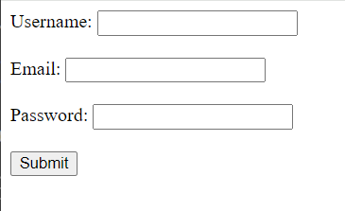Output:

Assignment:6

8.HTML program**.**

<!DOCTYPE html>

<html lang="en">

<head>

<meta charset="UTF-8">

<title>Assignment</title>

</head>

<body>

<h1>

This is my Table

</h1>

<table border = "5" cellspacing = "40" celpadding = "40">

<tr>

<td rowspan = "2">

<h2>

Tanisha Islam

</h2>

<h3>

Skills:

</h3>

<p>

Familar with -:

Databses-:MySQL<br>

Familiar and proficient in C++<br>

Data structures and algorithms

</p>

<h3>

Academics:

</h3>

<p>

High-School -: Passed with 76% from WBCHSE board, from Paikar Dew Drop School <br>

Senior-secondary -: Passed with 78% from WBCHSE board, from Rampurhat Girls High school<br>

Current SGPA -: 7.4

</p>

<h3>

Contact Details:

</h3>

<p>

Email - tanishaaman2003@gmail.com<br>

Contact number - 8967408090

</p>

</td>

<td><iframe src = "index.html" width = "width-value" height = "height value"></iframe></td>

</tr>

<tr>

</tr>

<tr>

<td colspan = "2">

<a href= "www.linkedin.com/in/tanisha-aman-74285a323" target = "_blank"> My LinkedIn profile</a>

</td>

</tr>

</table>

</body>

</html>

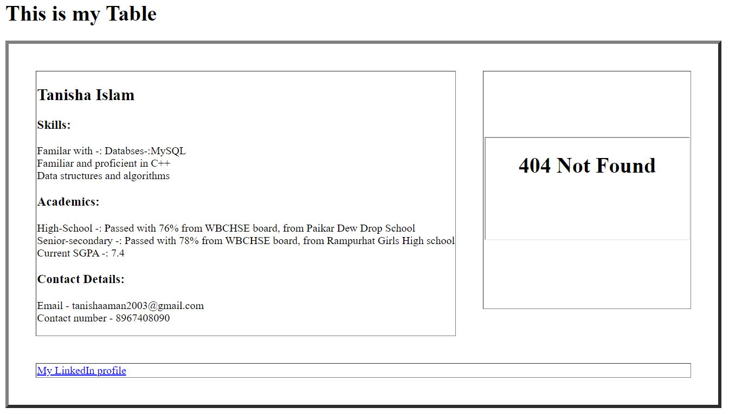Output: